33.18: (a)
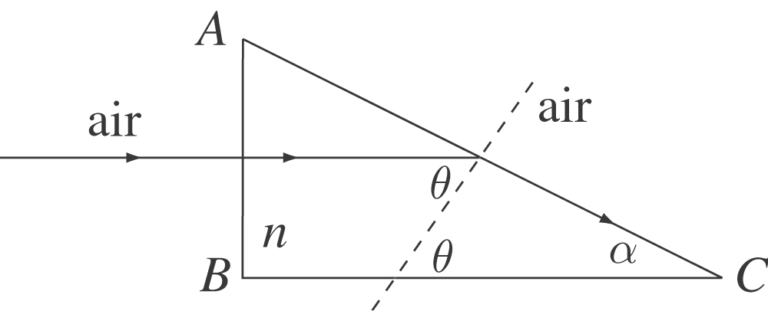
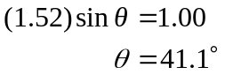
largest that α can be.

(b) Same approach as in (a), except AC is now a glass-water boundary.
